Part 1.

Observation – “Which do you think is the correct reading?”

Because the x10 and x1 are both similar in the sense that x10*10=x1.We can assume that they are both equally correct.

Observation – What happened to the trace, provide explanations for your observations?

The DC wave moves up by 1 volt at every point due to the 1 volt DC offset. This shows the true voltage of the circuit. If you set the probe to AC coupling, it shows it stuck at the same spot, no matter what the DC offset is. This is due to the fact that when the oscilloscope is in AC coupling mode, it ignores the DC offset.

**Find value of R so that there is a 45 degree phase shift from Vin** to Vout

**Connect Vin** to function generator (set 1 volt p-p @ 1 kHz & 0 volts DC offset) Connect channel 1 of scope to V­in and channel 2 to Vout. You should now observe the relative time position of the circuit input and circuit output on scope. **Sketch these waveforms**

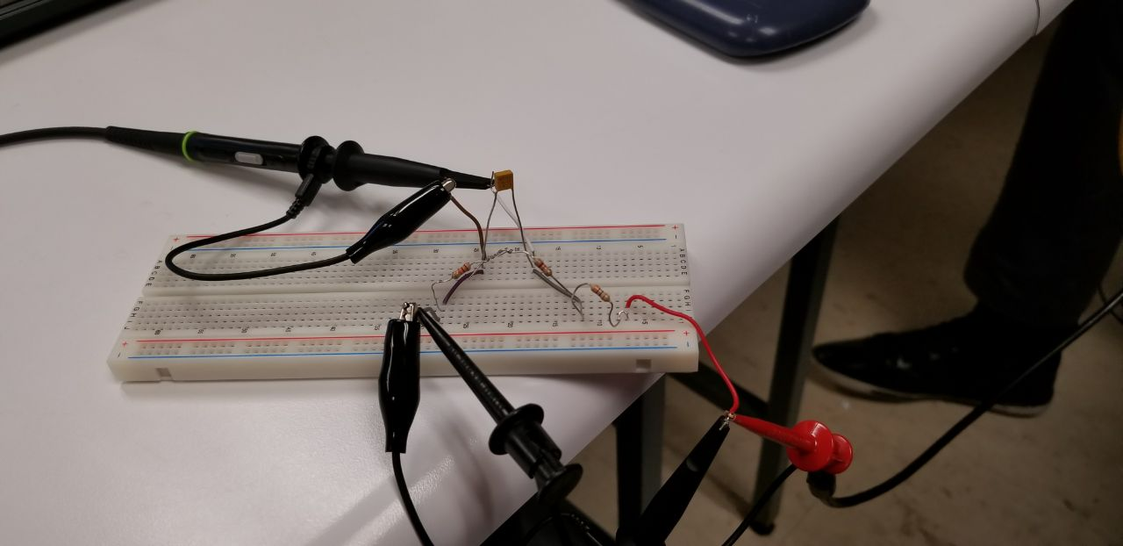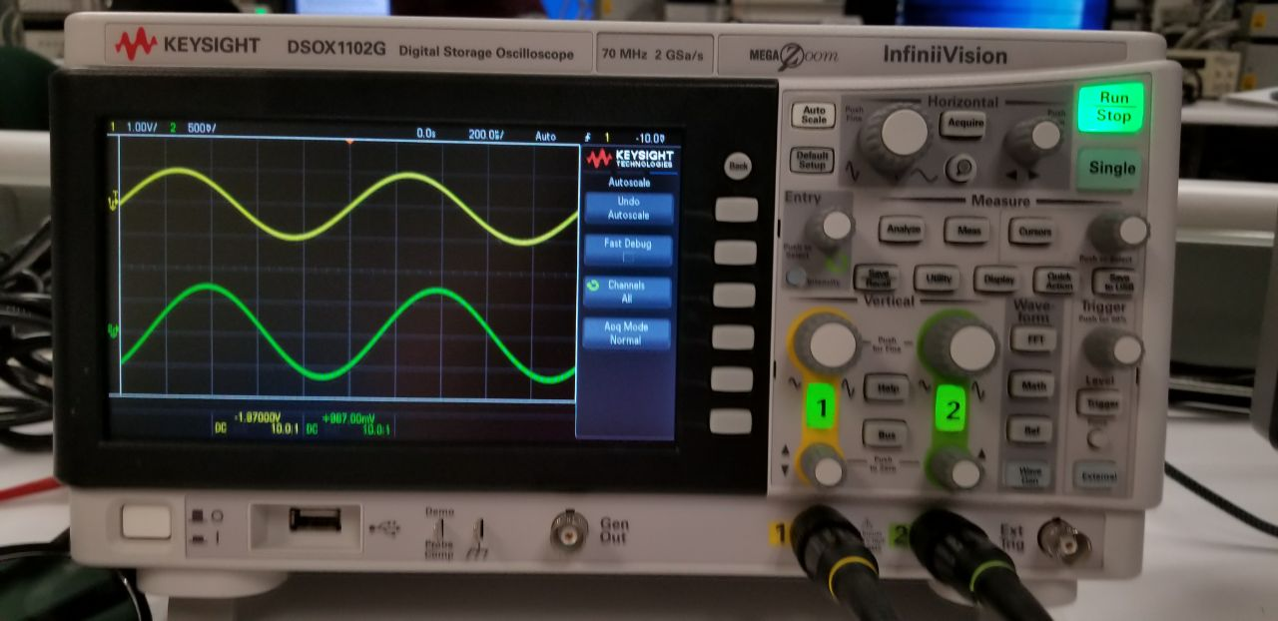

Adjust vertical pos of Channel 2 until signal is totally off screen. Observe small arrow pointing up to indicate that the channel 2 signal is at the top of the screen. Now adjust vertical pos to make it below screen. This allows user to find a waveform when it is off screen.

**Contain these comments and observations within data sheet**

**There should be space for 3 voltage measurements made on calibrator voltage**

Part 2.

**This part uses the same 1 Vp-p sine wave from part 1.**

Part 3

**This part uses 1 Vp-p 1KHz sine wave**